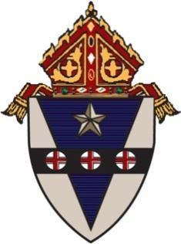

**ARCHDIOCESE OF PHILADELPHIA**

**OFFICE FOR COMMUNICATIONS**

222 North Seventeenth Street ● Philadelphia, Pennsylvania 19103-1299

Telephone (215) 587-3747 ● commof@archphila.org ● [www.archphila.org](http://www.archphila.org)

**For Immediate Release** Contact: Matthew Gambino

February 26, 2025 Deputy Communications Officer

215-587-3747 *(office)*

**ARCHBISHOP NELSON J. PÉREZ SENDS LETTER TO THE MUSLIM FAITH COMMUNITY ON THE OCCASION OF RAMADAN**

Dear Friends of the Muslim Faith Tradition,

Together with the people of the Catholic Church in Philadelphia, I send warm greetings of friendship as you mark the observance of Ramadan.

In 2019, the “Document on Human Fraternity” signed by Pope Francis and the Grand Imam of al-Azhar, Ahmed el-Tayeb, stated “that authentic teachings of religions invite us to remain rooted in the values of peace; to defend the values of mutual understanding, human fraternity and harmonious coexistence; to re-establish wisdom, justice and love; and to reawaken religious awareness among young people.”

I share their vision of mutual deep respect and friendship between Christians and Muslims, rooted in hopes for peace in a time when conflict around the world results in suffering, death, and devastation for many people.

May your month-long vigil of prayer, fasting, and works of mercy be fruitful. May you share compassionate love with all those you encounter as instruments of peace.

*Most Reverend Nelson J. Pérez, D.D.  
Archbishop of Philadelphia*